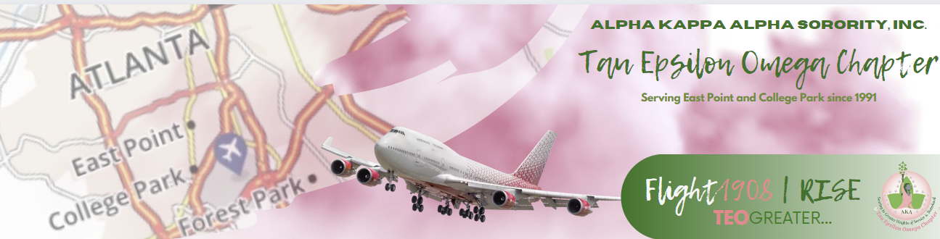 **Connections & Social Action Committee Agenda**

*October 2024 Committee Meeting*

*October 7, 2024, 6:30 PM*

*Zoom*

[*https://us02web.zoom.us/j/9952637222?pwd=aldZa0t2a0ExTEdZUDhlZWRTeWlEQT09&omn=82697195911*](https://us02web.zoom.us/j/9952637222?pwd=aldZa0t2a0ExTEdZUDhlZWRTeWlEQT09&omn=82697195911)

*Meeting ID: 995 263 7222*

*Passcode: pinkivy*

**Summary:** Article I, Section 15, (i) of the Constitution and Bylaws provides that: the Connection Committee “shall consist of a chairman and a representative from each region. The Committee shall identify and study national and international issues which impact quality of life, design strategies for communication with the membership regarding issues, and mobilize the membership for action to formulate and recommend position statements to the Supreme Basileus and/or the Directorate.

* Call to Order
* Prayer
* Bowden Center Update
* State Election Board Update
* Party at the Polls Check In

**Budget Update:**

|  |  |
| --- | --- |
|  | Committee| Officer (i.e. Program Committee) |
| **Total 2024 Budget** |  |
| **Expenditures to Date** |  |
| Budget Remaining |  |
|  |  |

**Upcoming Meeting and Events:**

|  |  |  |
| --- | --- | --- |
| **Date & Time** | **Subject** | **Location Information** |
| **10/12/2024 @ 10:08 AM** | **Chapter Meeting** | **Friendship Church** |
| **10/19/2024 @ 2:00 PM** | **Party at the Polls** | **2300 Godby Road** |
|  |  |  |
|  |  |  |
|  |  |  |
|  |  |  |
|  |  |  |